VPC
Assignment 1:

1.Create VPC with 2 private and 2 public subnets.
2.Enable DNS Hostname in VPC.
3.Enable Auto Assign Public IP in 2 public subnets.
4.Add 2 private subnets in private route table.
5.Add 2 public subnets in public route table.
6.Public route table will have the routes to internet and local.
7.Create EC2 in public subnet with t2.micro and install PHP.
8.Configure NAT gateway in public subnet and connect to private instance.
9.Install Apache Tomcat in private EC2 and deploy a sample app.
10.Configure VPC flow logs and store the logs in S3 and CloudWatch.

1: Create VPC with 2 private and 2 public subnets:
Step 1: Create VPC
1. Go to AWS Console → VPC.
2. Click Create VPC.
3. Select VPC and more.
4. Enter:
o Name: Task-VPC-vpc
o IPv4 CIDR: 10.0.0.0/16
5. Configure:
o Number of Availability Zones: 2
o Number of public subnets: 2
o Number of private subnets: 2
o NAT Gateway: 1 per AZ or as required by your task.
6. Keep the remaining settings as default unless your task specifies otherwise.
7. Click Create VPC.
Step 2: Verify the VPC
Go to VPC → Your VPCs and verify:
• VPC Name: Task-VPC-vpc
• IPv4 CIDR: 10.0.0.0/16
• State: Available
Step 3: Verify the 4 Subnets
Go to VPC → Subnets.
You should have:
Subnet Availability Zone Type
Task-VPC-subnet-public1-us-east-1a us-east-1a Public
Task-VPC-subnet-public2-us-east-1b us-east-1b Public
Task-VPC-subnet-private1-us-east-
1a us-east-1a Private
Task-VPC-subnet-private2-us-east-
1b us-east-1b Private
Step 4: Verify Route Tables
Go to VPC → Route Tables.
You should have:
• Task-VPC-rtb-public
• Task-VPC-rtb-private1-us-east-1a
• Task-VPC-rtb-private2-us-east-1b
The public route table should have:
0.0.0.0/0 → Internet Gateway
The private route tables should use the NAT Gateway for outbound internet access.
Step 5: Verify Network Connections
Check that you have:
• Internet Gateway: Task-VPC-igw
NAT Gateway: Task-VPC-nat-public1-us-east-1a
• S3 VPC Endpoint: Task-VPC-vpce-s3
Final verification
Your architecture should look like:
Task-VPC-vpc
10.0.0.0/16
│
├── Public Subnet 1 ── us-east-1a
│ └── Internet Gateway
│
├── Public Subnet 2 ── us-east-1b
│ └── Internet Gateway
│
├── Private Subnet 1 ── us-east-1a
│ └── NAT Gateway
│
└── Private Subnet 2 ── us-east-1b
└── NAT Gateway

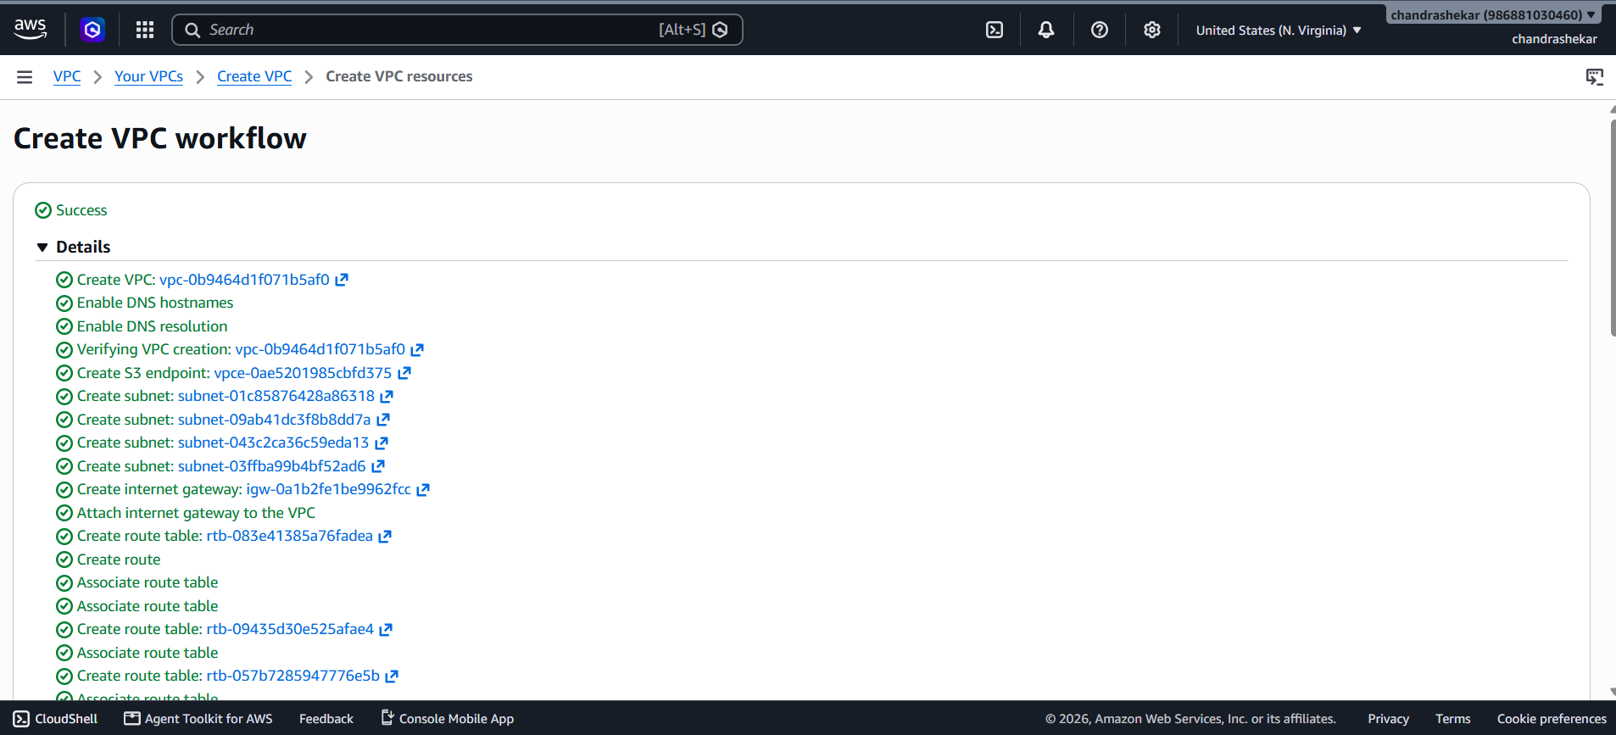
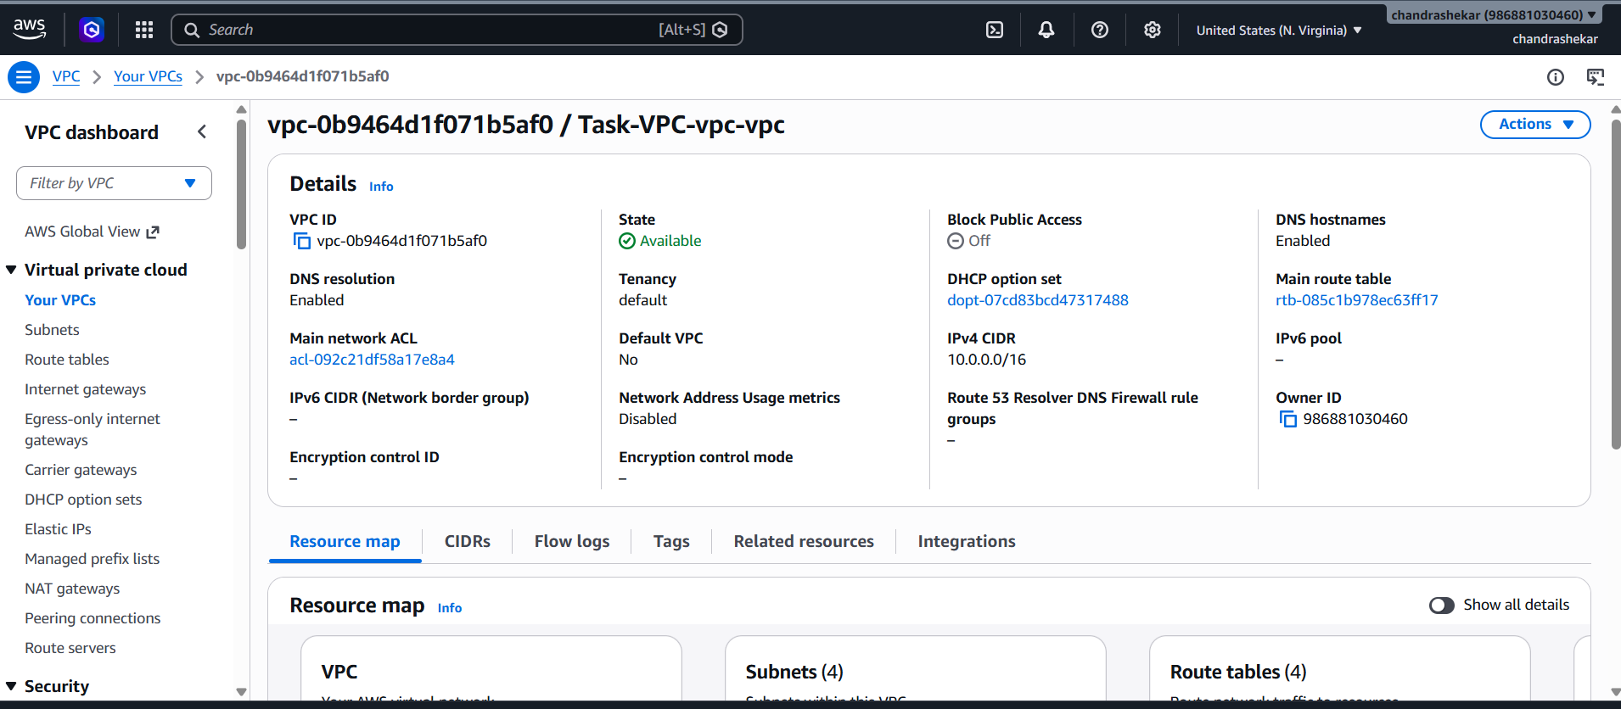
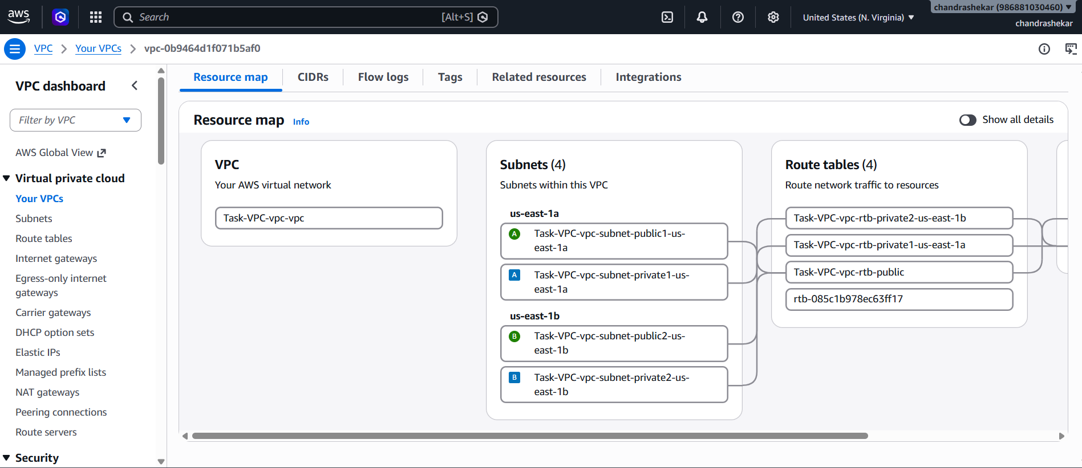

2: Enable DNS Hostname in VPC.
Enable DNS Hostnames
1. Go to VPC → Your VPCs.
2. Select Task-VPC-vpc.
3. Go to Actions → Edit VPC settings.
4. Under DNS settings, enable:
o DNS hostnames
o DNS resolution
5. Click Save.
Verify: VPC details should show DNS hostnames: Enabled
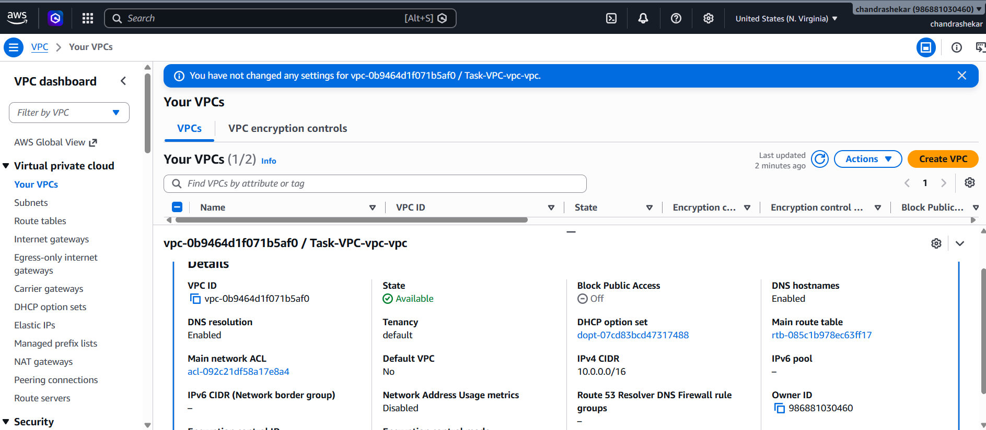
3: Enable Auto Assign Public IP in 2 public subnets.
1. Go to VPC → Subnets.
2. Select Public Subnet 1.
3. Actions → Edit subnet settings.
4. Enable Auto-assign public IPv4 address.
5. Click Save.
6. Repeat for Public Subnet 2.
Verify: Both public subnets show Auto-assign public IPv4: On
Status: Completed when both are On
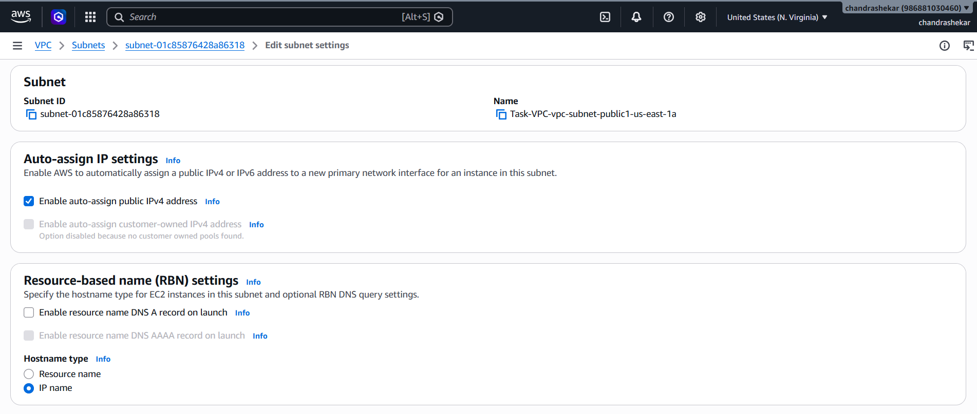
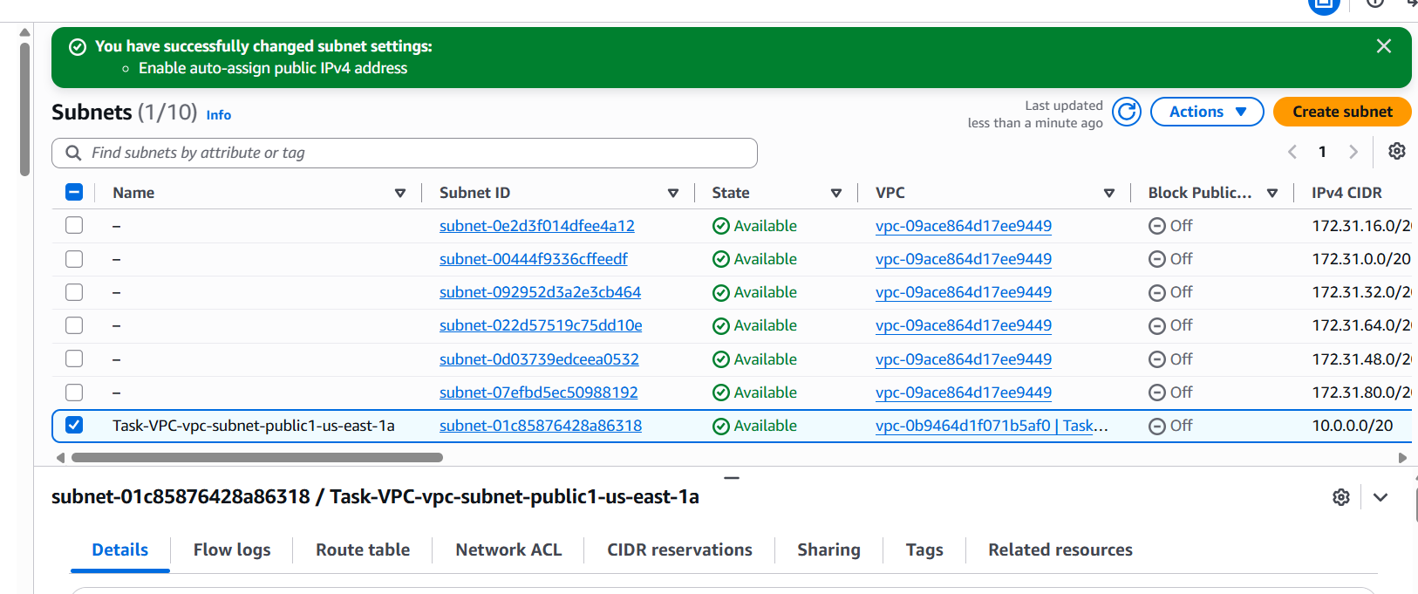

4: Add 2 private subnets in private route table.
• Go to VPC → Route Tables.
• Select Task-VPC-rtb-private1-us-east-1a.
• Go to Subnet associations → Edit subnet associations.
• Select Task-VPC-subnet-private1-us-east-1a.
Click Save associations.
• Select Task-VPC-rtb-private2-us-east-1b.
• Go to Subnet associations → Edit subnet associations.
• Select Task-VPC-subnet-private2-us-east-1b.
• Click Save associations.
Private Subnet 1 → Task-VPC-rtb-private1-us-east-1a → Successfully updated
Private Subnet 2 → Task-VPC-rtb-private2-us-east-1b → Already associated

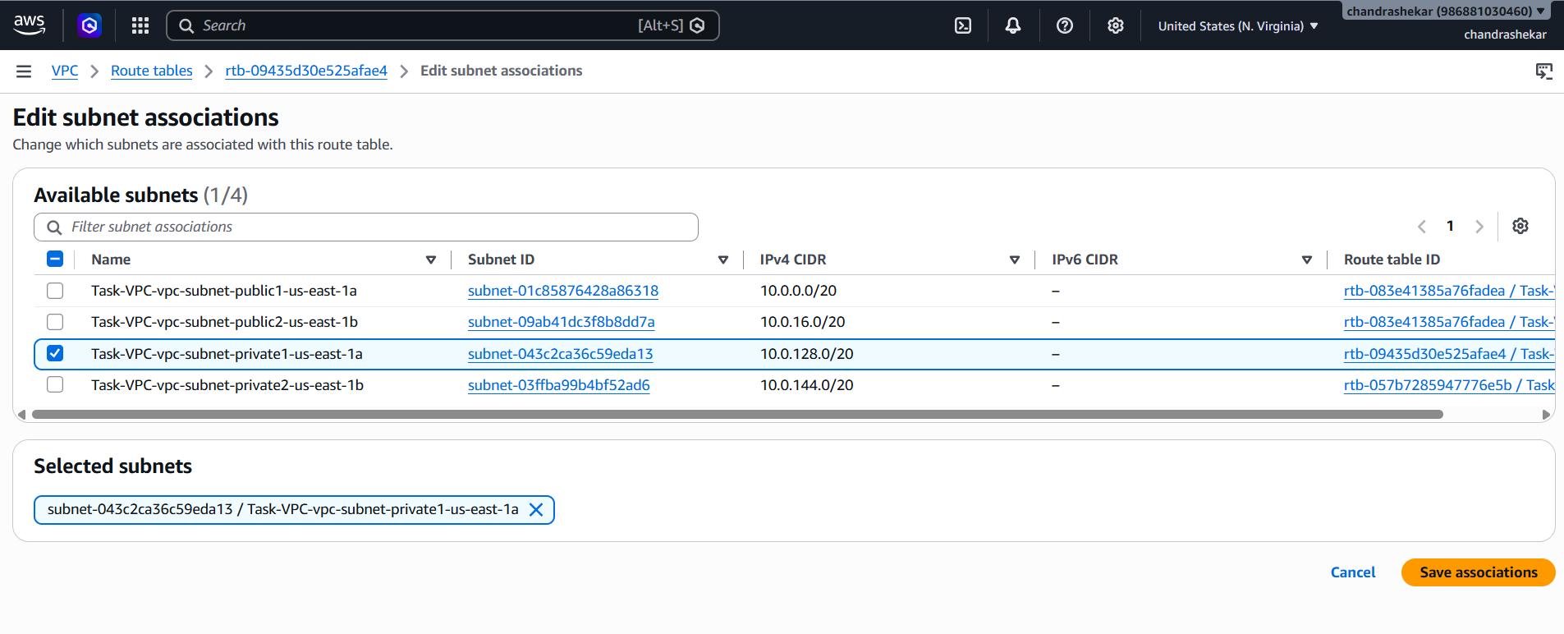
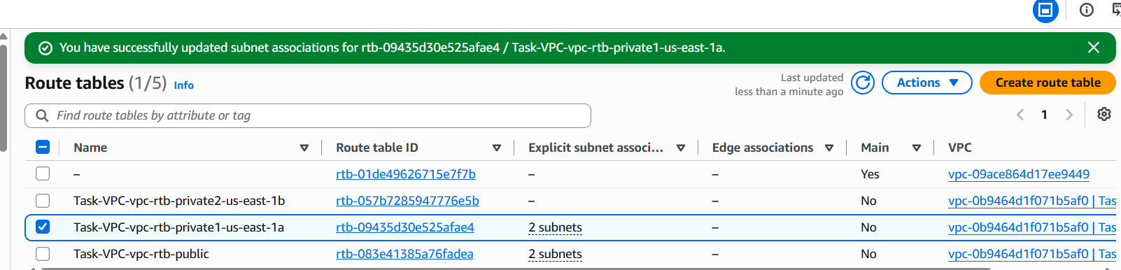

5: Add 2 public subnets in public route table.
1. Go to VPC → Route Tables.
2. Select Task-VPC-rtb-public.
3. Go to Subnet associations.
4. Click Edit subnet associations.
5. Select:
o Task-VPC-subnet-public1-us-east-1a
o Task-VPC-subnet-public2-us-east-1b
6. Click Save associations.
Verify
• Public Subnet 1 → Task-VPC-rtb-public
• Public Subnet 2 → Task-VPC-rtb-public
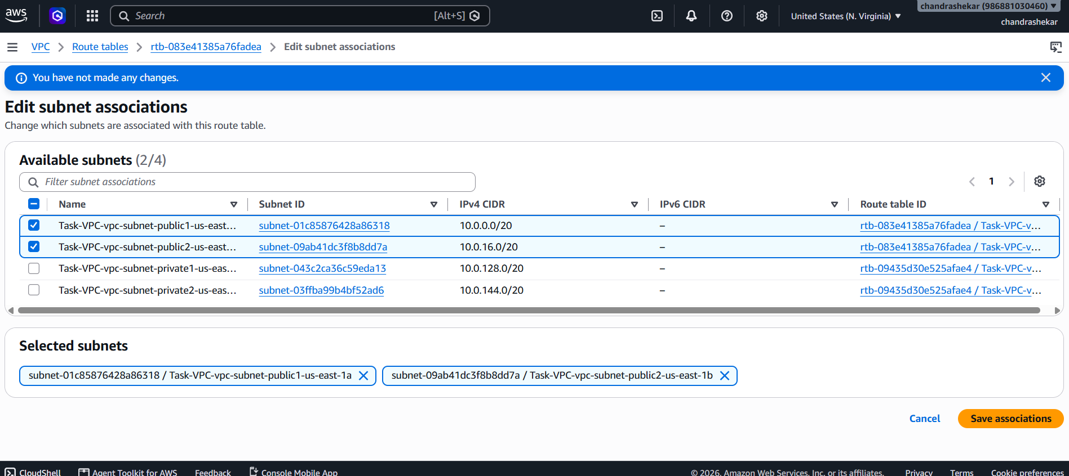
6: Public route table will have the routes to internet and local.
Go to VPC → Route Tables.
Select Task-VPC-rtb-public.
Open the Routes tab.
Click Edit routes.
Verify these routes:
• 10.0.0.0/16 → local
• 0.0.0.0/0 → igw-000b01d699ce933d8
If both routes already exist, no changes are required.
Click Cancel if AWS says "You have not made any changes."
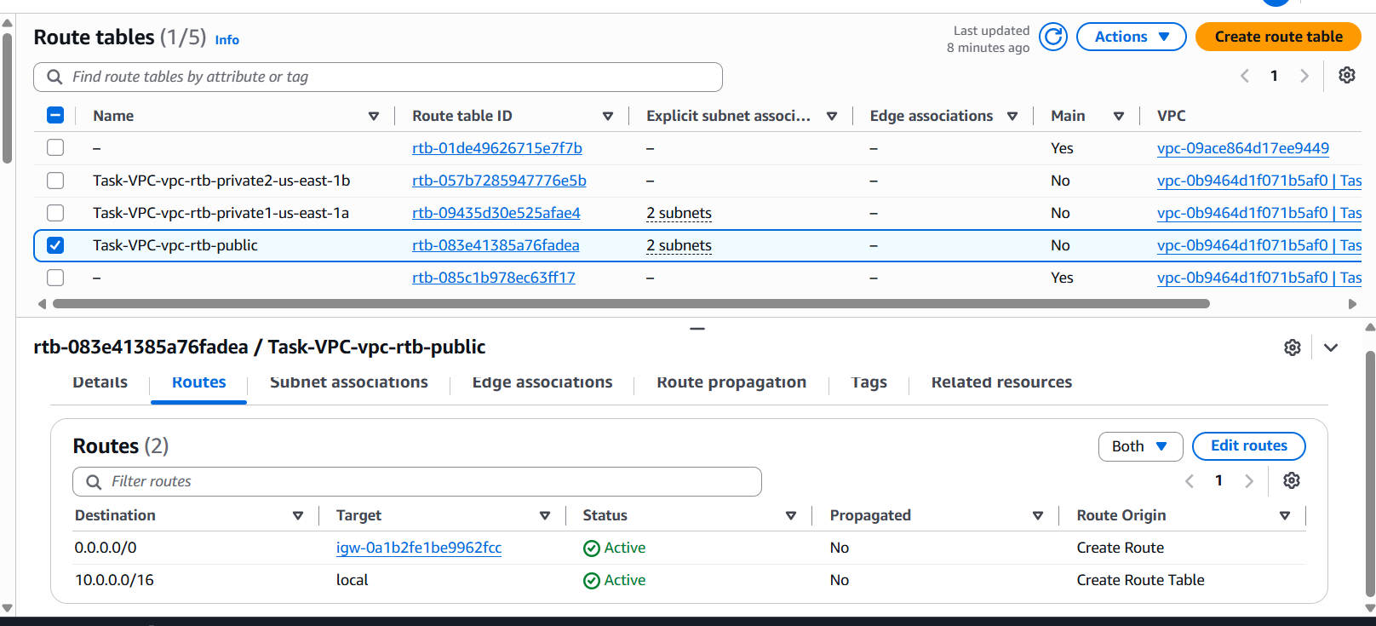

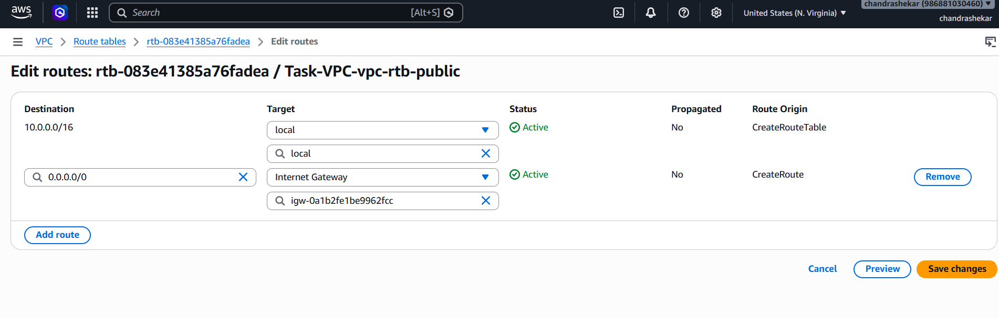

7: Create EC2 in public subnet with t2.micro and install PHP.
1. Go to AWS Console → EC2 → Instances.
2. Click Launch instance.
3. Name: Task7-PHP
4. AMI: Choose Amazon Linux 2 (if your task doesn't specify another OS).
5. Instance type: t2.micro.
6. Key pair: Select your existing key pair.
7. Under Network settings → Edit:
o VPC: Task-VPC-vpc
o Subnet: Task-VPC-subnet-public1-us-east-1a
o Auto-assign Public IP: Enable
8. Create/select a security group.
9. Allow:
o SSH (22) → My IP
o HTTP (80) → 0.0.0.0/0
10. Under Advanced details → User data, enter the PHP installation script.
11. Click Launch instance.
User Data for PHP
For Amazon Linux 2:
#!/bin/bash
yum update -y
amazon-linux-extras enable php8.0
yum clean metadata
yum install -y php
Step 2: Verify
After the instance starts, connect to it through SSH and run:
Command: php -v
Status
• EC2 in public subnet
• Instance type t2.micro
• Public IP enabled
• PHP installed
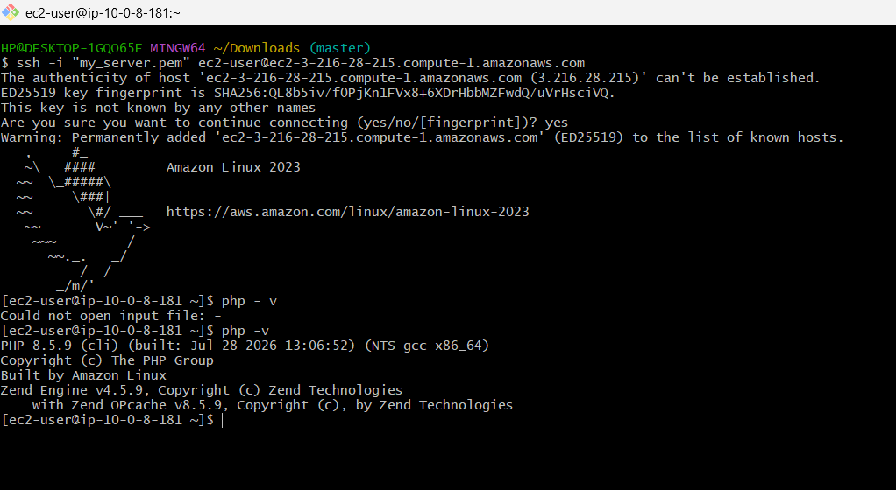

8: Configure NAT gateway in public subnet and connect to private instance.
• NAT Gateway in public subnet →ok
• NAT Gateway is Available →ok
• Private route table uses NAT Gateway →ok
• Private EC2 created →ok
• Private EC2 has no public IP →ok
• Connected from public EC2 to private EC2 →ok
successfully connected:
Windows PC
↓ SSH
Public EC2
10.0.15.38
↓ SSH
Private EC2
10.0.131.58
Your prompt:
[ec2-user@ip-10-0-131-58
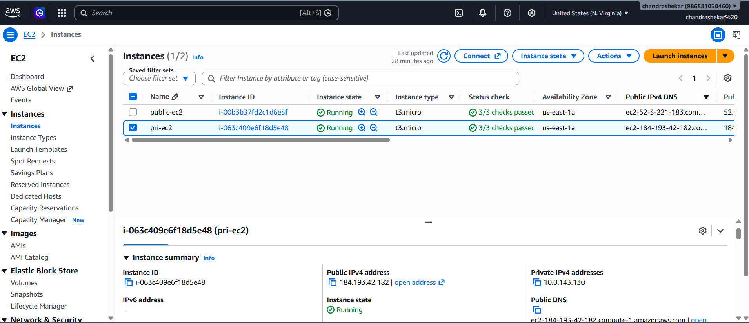
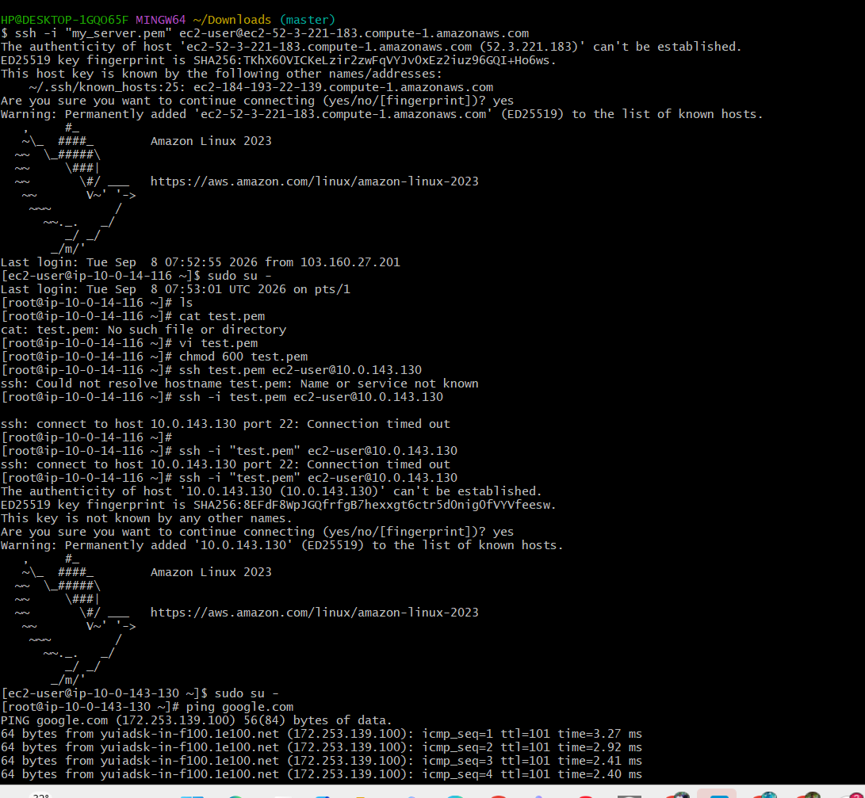

9: Install Apache Tomcat in private EC2 and deploy a sample app.
Error SS: 404 NOT FOUND DUE TO OLD VERSION INSTALL
Used this: sudo wget https://dlcdn.apache.org/tomcat/tomcat-10/v10.1.59/bin/apache-tomcat-10.1.59.tar.gz
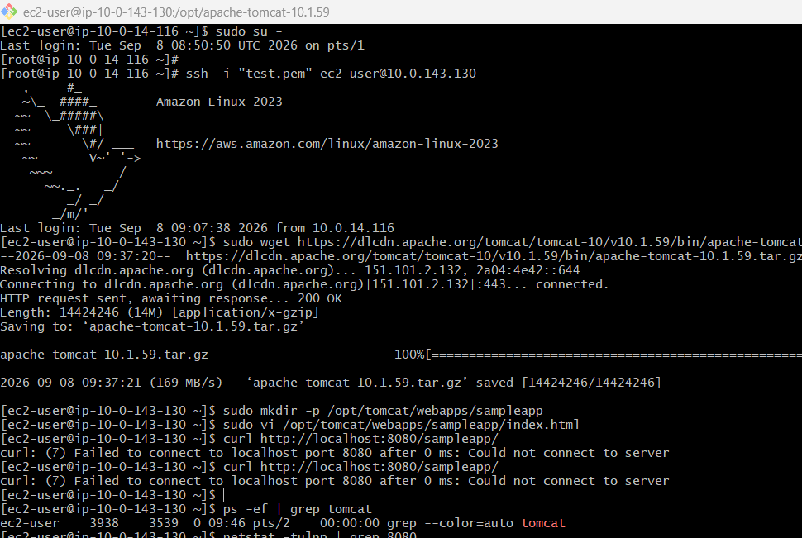
sudo mkdir -p /opt/tomcat/webapps/sampleapp
sudo vi /opt/tomcat/webapps/sampleapp/index.html
Add:
<html>
<head>
<title>Task 9</title>
</head>
<body>
<h1>Hello from Private EC2 Tomcat!</h1>
</body>
</html>
And Save :wq!
curl http://localhost:8080/sampleapp/
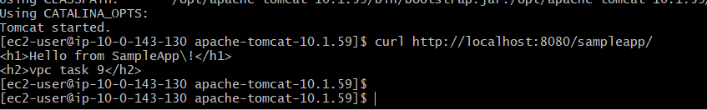
10: Configure VPC flow logs and store the logs in S3 and CloudWatch.
Part 1: Flow Logs → S3
- VPC → Your VPCs → Task-VPC-vpc
- Actions → Create flow log
- Name: Task-VPC-FlowLog-S3
- Filter: All
- Aggregation: 10 minutes
- Destination: Send to an Amazon S3 bucket
- Create/select S3 bucket.
- Enter S3 ARN:
arn:aws:s3:::task-vpc-flow-logs-929523583693
- Create flow log ✅
Part 2: Flow Logs → CloudWatch

Open VPC Console
Start from the AWS Management Console to access your VPC.
AWS Console → VPC → Your VPCs
- Select your VPC (example: Task-VPC-vpc)
- Go to Flow logs tab

Create Flow Log
Initiate a new flow log for CloudWatch monitoring.
Click Create flow log
- Name: Task-VPC-FlowLog-CloudWatch
- Filter: All (captures accepted + rejected traffic)

Set Aggregation Interval
Choose how often logs are delivered.
- Select 10 minutes (or 1 minute if needed)

Choose Destination
Send logs to CloudWatch for monitoring and alerts.
- Destination: Send to CloudWatch Logs
- Log group: /aws/vpc/Task-VPC-flow-logs

Configure IAM Role
CloudWatch needs permission to receive logs.
- Select Create and use a new service role
- Role name example: VPCFlowLogs-Cloudwatch-1787826573332

- VPC → Task-VPC-vpc → Flow logs → Create flow log
- Name: Task-VPC-FlowLog-CloudWatch
- Filter: All
- Aggregation: 10 minutes
- Destination: Send to CloudWatch Logs
- Log group:
/aws/vpc/Task-VPC-flow-logs
- Service access: Create and use a new service role
- Select the created role:
VPCFlowLogs-Cloudwatch-1787826573332
- Create flow log ✅
Final check
Both should show State: Active:
Task-VPC-FlowLog-S3 → S3 ✅
Task-VPC-FlowLog-CloudWatch → CloudWatch ✅
· VPC Flow Logs
↓
┌───┴────────┐
↓ ↓
S3 CloudWatch
Storage Monitoring/Logs

